Ideation Phase
Brainstorm & Idea Prioritization Template

Date | 28 September 2026
Team ID | SWTID-2026-5228
Project Name | Import Data using Transform Maps (Spreadsheet)
Maximum Marks | 4 Marks

Brainstorm & Idea Prioritization Template:
Brainstorming provides a free and open environment that encourages everyone within a team to participate in the creative thinking process that leads to problem solving. Prioritizing volume over value, out-of-the-box ideas are welcome and built upon, and all participants are encouraged to collaborate, helping each other develop a rich amount of creative solutions.
Use this template in your own brainstorming sessions so your team can unleash their imagination and start shaping concepts even if you're not sitting in the same room.
Reference: https://www.mural.co/templates/brainstorm-and-idea-prioritization
Step-1: Team Gathering, Collaboration and Select the Problem Statement
Problem statement: How might we import bulk employee data from Excel into ServiceNow accurately and without duplicate records?
Our team of five (team size: 5) gathered on the ServiceNow Personal Developer Instance (PDI) and agreed to build a micro project that loads employee data from a spreadsheet into a custom table using an Import Set and a Transform Map. The team members and their assigned tasks are listed below (estimated times are from the SkillWallet task cards).
Team Member | Role | Assigned Tasks | Estimated Time
Divya Shree S | Team Leader – Data Transformation & Validation | Transform data & validate | 3 hr 20 min
Harini V | Spreadsheet & Table Setup | Create spreadsheet, create tables, create Import Set table | 1 hour
Harshini S | Transform Map & Reporting | Create Transform Map, Report 1, add reports to dashboard | 1 hour
Harshini K | Duplicate Prevention | Enable Coalesce to avoid duplicate records | 3 hr 20 min
Harshini P | Data Insertion | Insert new data in Excel format | 3 hr 20 min
Overall estimated time for all 9 tasks: 12 hours.
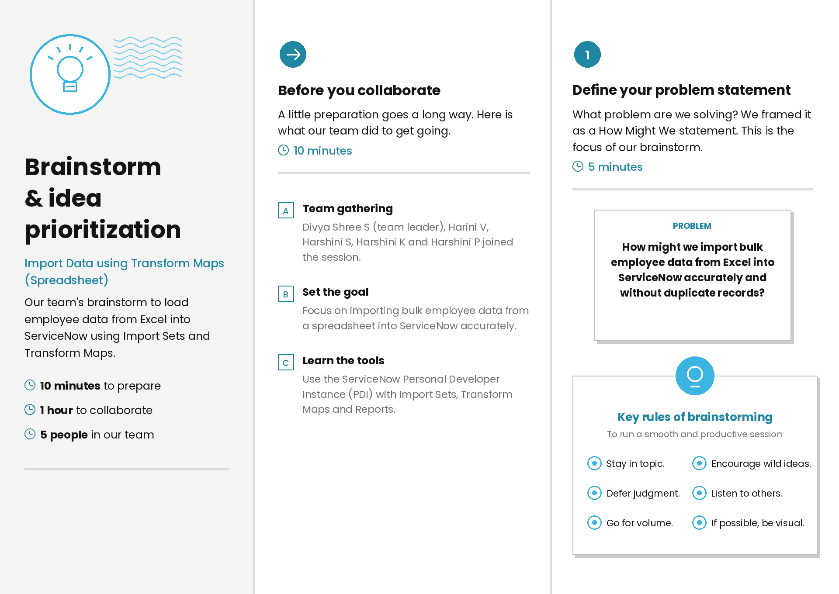

Step-2: Brainstorm, Idea Listing and Grouping
Each member brainstormed ideas based on their assigned task. The ideas were then grouped into four themes:
• Data preparation: sample employee spreadsheet, custom table u_employee_test, Import Set staging table.
• Mapping & transform: create the Transform Map, auto-map matching fields, run the transform and check history.
• Data quality: Coalesce on Employee ID, validate records after transform, re-import to confirm no duplicates.
• Reporting: pie chart by department, bar chart by location, add reports to a dashboard.

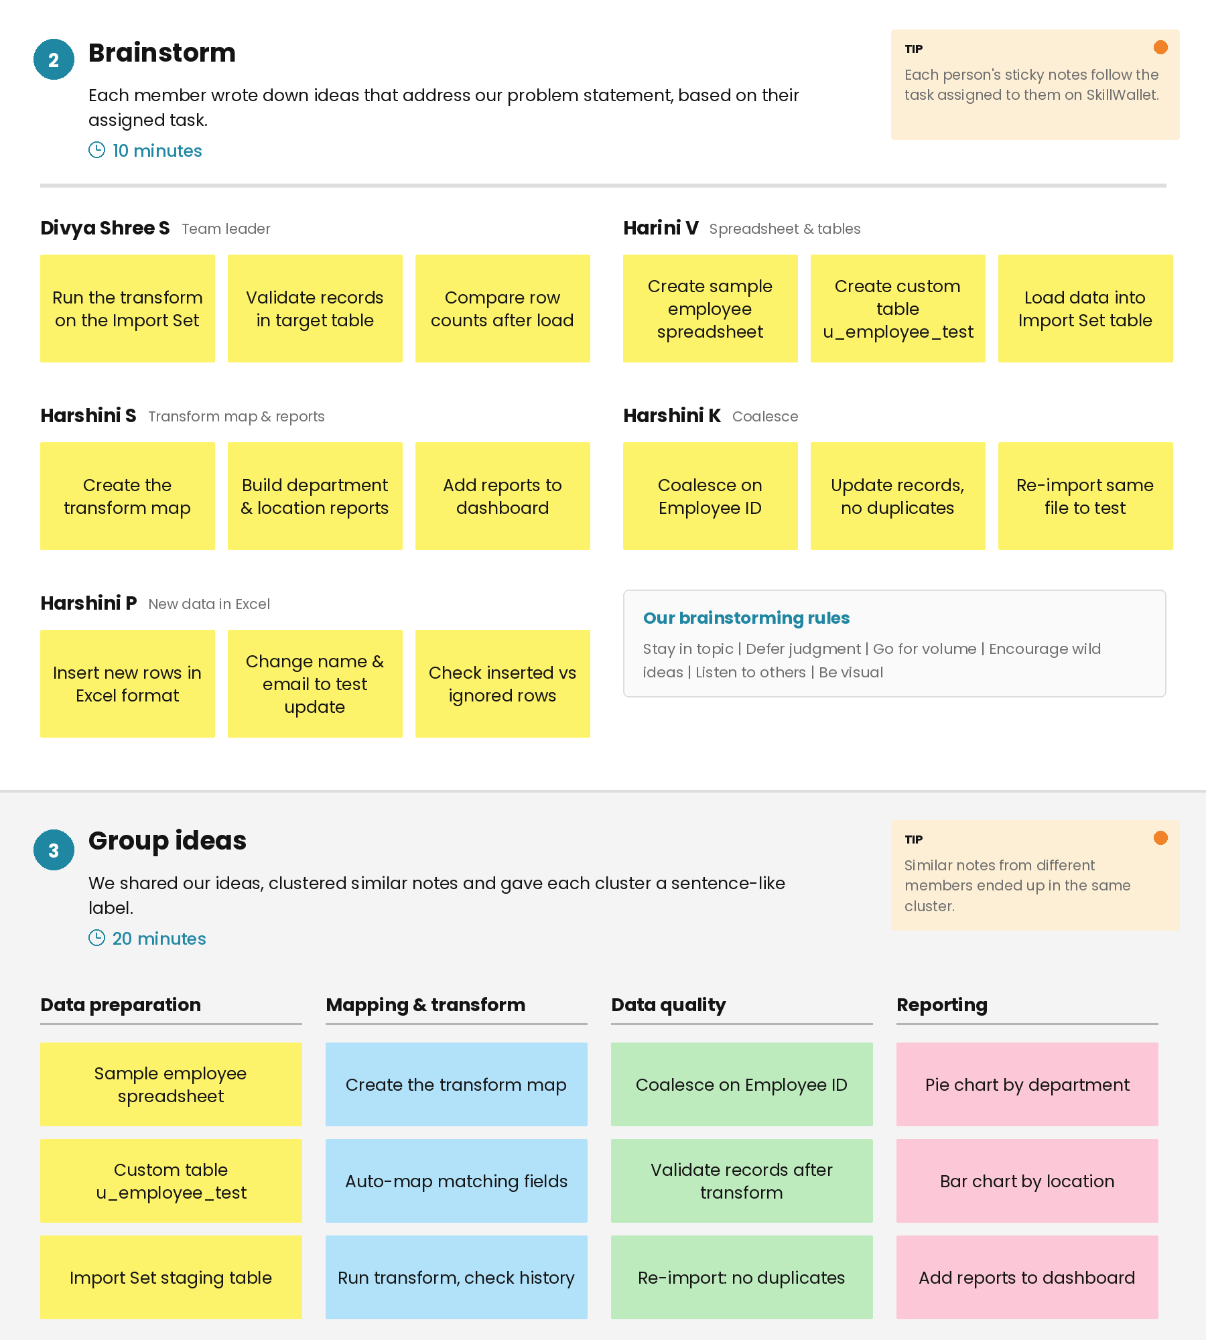

Step-3: Idea Prioritization
The ideas were placed on an Importance vs Feasibility grid. The top-priority ideas (high importance, high feasibility) were:
• Create the Transform Map – it connects the Import Set table to the Employee Test table, so every other step depends on it.
• Enable Coalesce on Employee ID – updates existing records instead of inserting duplicates when the same data is imported again.
• Validate records after transform – confirms the imported data in the Employee Test table is correct.
Reports and dashboard ideas were rated easy to build but lower in importance, so they were scheduled after the core import was working.
